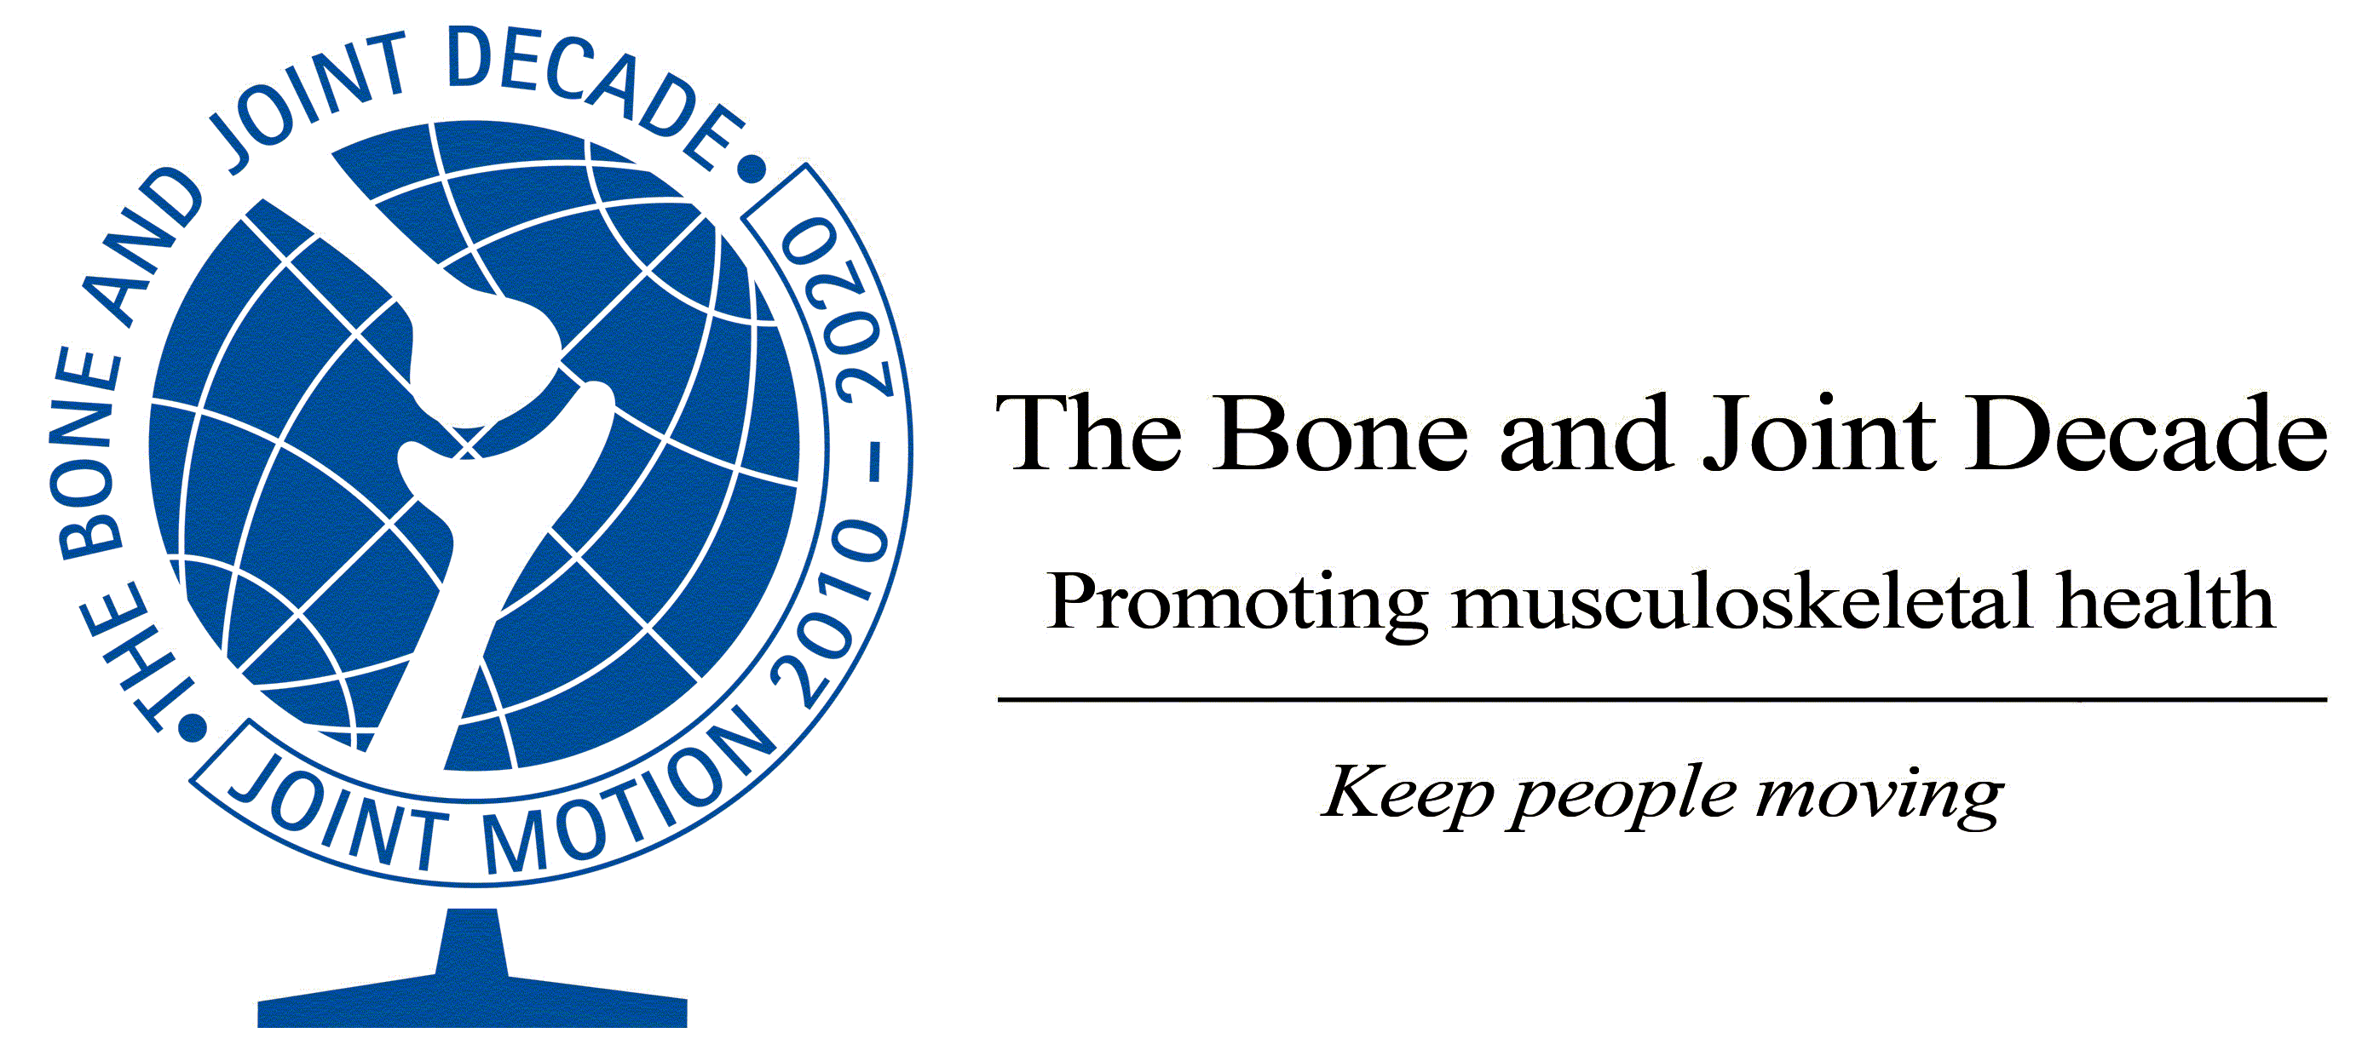
Global Alliance for Musculoskeletal Health
Press Release
Influential global alliance calls on governments and the World Health Organisation to prioritise musculoskeletal health following findings of Global Burden of Disease Study 2010
The Bone and Joint Decade (BJD), the only organisation that brings together stakeholders considering all musculoskeletal conditions, calls for urgent action to “keep people moving” and reduce the burden of disability

Truro, UK 15th December 2012
Musculoskeletal conditions are the second greatest cause of disability globally according to a report by international experts, published in The Lancet on 15th December 2012. In the first comprehensive study of the worldwide impact of all diseases and risk factors, musculoskeletal (MSK) conditions such as arthritis and back pain affect over 1.7 billion people worldwide, and have the fourth greatest impact on the overall health of the world population, considering both death and disability. This burden has increased by 45% over the last 20 years and will continue to do so unless action is taken. This landmark study of the global burden of all diseases provides indisputable evidence that musculoskeletal conditions are an enormous and emerging problem in all parts of the world and need to be given the same priority for policy and resources as other major conditions like cancer, mental health and cardiovascular disease.
Professor Anthony Woolf, from the Royal Cornwall Hospital, Truro, UK and Chair of the Bone and Joint Decade (BJD) International Co-ordinating Council, said: “Across the world, health policy has ignored diseases which affect the quality of lives and independence of people living with them and focused on those with high mortality such as infectious diseases, and more recently on cancer, heart disease and diabetes. Now it is time for priority to be placed on dealing with this enormous burden from arthritis, back pain and other musculoskeletal conditions to prevent unnecessary pain and disability. Despite there being effective ways of preventing and treating these conditions, many people do not have access to them because they are not a priority. This data justifies what the BJD has been campaigning for over the past ten years.” This call is echoed by Professor Christopher Murray and the authors of the study who say that “health systems will need to address the needs of the rising numbers of individuals with a range of conditions that largely cause disability, not mortality”.

The Global Burden of Disease 2010 Project is led by Professor Christopher Murray, Institute for Health Metrics and Evaluation, Seattle, the World Health Organisation and involves researchers from around the world. Leader of the MSK Expert Group Lyn March, University of Sydney, Australia said: “This data provides the clearest evidence to date of the huge and increasing burden on global health from musculoskeletal conditions. It shows that lower back pain is the leading cause of disability and osteoarthritis is one of the fastest growing conditions. We need clear action to reverse this situation and to keep people moving and living without pain and disability.”

Neil Betteridge, a patient advocate, Vice President of EULAR representing People with Arthritis and Rheumatism in Europe (PARE), and Policy Lead at the British Society for Rheumatology said “The finding that musculoskeletal conditions are the second greatest cause of disability globally should drive policy changes for the millions of people living with these painful and disabling problems. Despite the huge personal, social and economic impact of rheumatic and musculoskeletal conditions, policymakers have not prioritized them but this is now set to change."

“Since the launch in 2000, the Bone and Joint Decade has done much to change priorities by identifying the effect these conditions have on people and on society. Now we need actions by policy makers to prioritise preventing and treating these conditions to avoid people having unnecessary disability and pain,” says Professor Woolf.

The Bone and Joint Decade is calling for urgent action by the World Health Organisation, the United Nations, and by national governments and for explicit plans to respond to the Global Burden of Disease 2010 results and the new ranking which shows that musculoskeletal conditions have an enormous and growing impact in all regions of the world.

Contact Details
Bone and Joint Decade
bjd@cornwall.nhs.uk

Prof Anthony D Woolf +44 (0) 7836 623725

KEY FACTS
- Musculoskeletal conditions include joint diseases such as osteoarthritis and rheumatoid arthritis; back and neck pain; osteoporosis and fragility fractures; soft tissue rheumatism; injuries due to sports and in the workplace; and trauma commonly related to road traffic accidents
- They cause pain, physical disability and loss of personal and economic independence
- They affect millions of people of all ages in all cultures and in all countries
  - Current estimates of people affected worldwide (Lancet 15 December 2012)
    - Back pain 632.045 million
    - Neck pain 332.049 million
    - OA knee 250.785 million
    - Other musculoskeletal conditions 560.978 million
- They are the second greatest cause of disability, as measured by years lived with disability (YLDs) worldwide and across most regions of the world (Lancet 15 December 2012)
  - As a group musculoskeletal disorders cause 21·3% of all years lived with disability (YLDs) (this is second only to mental and behavioural disorders which account for 22.7% of YLDs)
  - The main contributors are low back pain (83.1 million YLDs), neck pain (33.6 million YLDs), osteoarthritis (17.1 million YLDs) and the other musculoskeletal category. Osteoarthritis of the knee accounts for 83% of the osteoarthritis total.
  - The leading cause of disability worldwide are low back pain contributing 10.7% of total YLDs (major depression contributes 8.1%).
- They have the fourth greatest impact on the health of the world population, considering both death and disability (DALYs) (Lancet 15 December 2012)
  - Musculoskeletal disorders account 6.8% DALYs
  - Low back pain accounts for nearly one half, neck pain one fifth, and osteoarthritis about 10%.
  - Ranking of major causes of death and disability (% DALYs)
    - Cardiovascular and circulatory diseases 11.8%
    - All neoplasms 7.6%
    - Mental and behavioural disorders 7.4%
    - Musculoskeletal disorders 6.8%
- Disability due to musculoskeletal disorders is estimated to have increased by 45% from 1990 – 2010 (Lancet) compared to a 33% average across all other disease areas. Osteoarthritis is the fastest increasing major health condition. This relates to ageing of the population, increased obesity and lack of physical activity.
- Disability due to musculoskeletal conditions can be effectively prevented by currently available interventions, such as accident prevention, modern treatment of arthritis and injuries, and by rehabilitation.
- The growing burden can be controlled if priority and resources are given to ensure access to these interventions.

The Bone and Joint Decade 2010 – 2020
The Global Alliance for Musculoskeletal Health
The Bone and Joint Decade works to reduce the burden and cost of musculoskeletal conditions to individuals, carers and society worldwide
The Bone and Joint Decade is a global alliance promoting musculoskeletal health. It is the only organisation that brings together all stakeholders considering all musculoskeletal conditions working with policy makers at national, regional and global levels. Launched in 2000, and remandated in 2010, The Bone and Joint Decade gains its strength from bringing together national and international professional, scientific and patient organisations. It is endorsed by the UN and WHO and support has been declared by over 60 governments. The Vision is to “Keep People Moving” so they can lead active independent lives.
The Bone and Joint Decade is focused on influencing health policy through evidence and advocacy, using its unified voice and global reach.
Our vision is a world where musculoskeletal health is a priority; where the prevention, treatment and care of any musculoskeletal disorders is of a high standard and con- sistently accessible in order to improve the health-related quality of life for people with, or at risk of a musculoskeletal condition.
The prevention and treatment of musculoskeletal conditions and injuries should be among the leading major health concerns in the minds, actions and funding priorities of international health agencies, governments, non-governmental organisations, medical and research com- munities, funders, media and the general public.
Our mission is to promote musculoskeletal health and science worldwide.
www.boneandjointdecade.org

bjd@cornwall.nhs.uk

