|  |  |  |
| --- | --- | --- |
|  |  | **ARMA logo compressed** |

**Bone and Joint Decade 2010 – 2020**

**Global Alliance for Musculoskeletal Health**

World Summit 2014

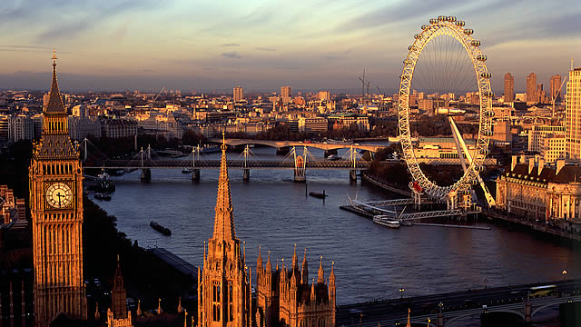

**London, 12 – 13 October, 2014**

|  |  |
| --- | --- |
| **Name:** |  |
| **Institution:** |  |
| **Address:** |  |
| **Country:** |  |
| **Telephone:** |  |
| **Fax:** |  |
| **Email Address:** |  |
| **Name & Phone of Emergency Contact:** |  |
|  |  |
| **ORGANISATION REPRESENTED:** |  |
| **POSITION IN ORGANISATION:** |  |
|  |  |
| **ARE YOU AN OFFICIAL NAN REPRESENTATIVE (2 per NAN)?** | YES ❒ NO ❒ |
| **ARE YOU AN OFFICIAL ARMA ORGANISATION REPRESENTATIVE (1 PER MEMBER ORGANISATION)?** | YES ❒ NO ❒ |
| **ARE YOU A PATIENT REPRESENTATIVE?** | YES ❒ NO ❒ |
| **ARE YOU FROM A COMMERCIAL / PROFIT-MAKING ORGANISATION?** | YES ❒ NO ❒ |

**Programme**

To see and save the full programme of events, please [click this link](http://arma.uk.net/wp-content/uploads/2014/06/Global-Alliance-for-Musculoskeletal-Health-London-meeting-10-2014-programme-020614.pdf).

**Registration**

I will attend:

|  |  |  |  |
| --- | --- | --- | --- |
| **Event** | **Number** | **cost** |  |
| **Sunday 12th October** |  |  |  |
| Meeting | **Fully Booked** | | |
| Evening Social Event | **Fully Booked** | | |

|  |  |  |  |
| --- | --- | --- | --- |
| **Monday 13th October** | **Number** | **cost** |  |
| Meeting |  |  | Delegate Fee £150, Commercial sector £500 (complimentary for official NAN and ARMA delegates) |
| Reception |  |  | Complementary |
| Conference Dinner |  |  | £45 per person |

|  |  |
| --- | --- |
| **TOTAL  COST** |  |

**Additional Attendees**

If you are completing this form on behalf of additional attendees please provide their details below:

|  |  |
| --- | --- |
| Name |  |
| Email address |  |
| Organisation |  |
| Position |  |

**There are a limited number of bursaries to contribute towards registration costs, in particular for patient representatives and people from low income countries. please indicate if you wish to be considered for a bursary YES ❒**

**Invoice details**

Please provide full invoice details below:

|  |  |
| --- | --- |
| Name |  |
| Email Address |  |
| Postal Address |  |

**Hotel Booking**

We have negotiated preferential rates at some hotels close to the meeting through Reservation Highway. Please follow this link: [www.reservation-highway.co.uk/arma14](http://www.reservation-highway.co.uk/arma14)

**MEETING VENUE**

Royal College of Surgeons, 35-43 Lincoln's Inn Fields, London WC2A 3PE, 020 7405 3474

[www.rcseng.ac.uk](http://www.rcseng.ac.uk)

**MAP OF AREA**

[Google Maps view of area around Waldorf Hilton Hotel, London](https://www.google.co.uk/maps/place/The+Waldorf+Hilton+Hotel+London/@51.5128444,-0.118929,17z/data=!4m2!3m1!1s0x487604caf5885343:0x4b72118b03a17fdf)

**Please send registration form to:** [projects@arma.uk.net](mailto:projects@arma.uk.net)

You will receive an invoice along with confirmation of your place at the meeting.